

Marketing

Feasibility Study



|  |  |
| --- | --- |
| Name | ID |
| Anas Hamed Mohamed | 4989 |
| Ibrahim Mostafa | 4715 |
| Islam Mustafa | 4595 |
| Mohannad Mahmoud | 5123 |
| Omar Ashraf | 4738 |
| Omar khattab | 5247 |
| Wadie Bishoy | 5074 |
| Karim Raafat Abdelmalek | 2465 |

OCTOBER 31, 2019

FEASIBILITY STUDY

Alexandria, Egypt

### ***Contents***

### ***ـــــــــــــــــــــــــــــــــــــــــــــــــــــــــــــــــــــــــــــــــــــــــــ***

Market Overview

Growing Sales........................................................................................................................................

Marketing Mix Tactics ..............................................................................................................................

Infrastructure demand

SWOT Analysis………………………………………………………………………………………………….

Competitor analysis……………………………………………………………………………………………..

Market segmentation

Market Growth

Forecasting market demand

Usefulness of demand forecasting

The scope of forecasting

Types of forecasting

Electric vehicle charging infrastructure2019:2029 forecasting

Growth of EV charging points around the globe

Short-term load forecasting for EV charging stations

Trend forecasting…………………………………………………………………………………………………

Forecasting using pattern……………………………………………………………………………………….

Forecasting with caution…………………………………………………………………………………………

Forecast accuracy………………………………………………………………………………………………..



### ***Market Overview***

### ***ـــــــــــــــــــــــــــــــــــــــــــــــــــــــــــــــــــــــــــــــــ***

Marketing study is a study that analyses market demand for a particular product or service. It analyses the activities in a market in regard to such influences as location, demand, and competition which may or may not affect the value of property. It aims to evaluate the impact of certain marketing instruments on customer behaviour. A marketing study is often associated with the [marketing mix](http://www.1819.be/en/marketing-sales-e-commerce/basic-concepts/marketing-mix). Its purpose is to make a company's marketing process more effective.

The electric vehicle charging station market is expected to record a CAGR of 38.45% during the forecast period, 2019-2024. The electric vehicles (EV) market has been witnessing significant growth, owing to the growing environmental concerns and rising demand for sustainable and energy efficient transportation.

* Growing adoption and sales of electric vehicles, along with the enactment of laws and subsidies for promoting the adoption of EVs and declining cost of batteries, are some of the major factors propelling the growth of the market.
* Global plug-in vehicle deliveries reached 2.1 million units for 2018, which is 64% higher than for 2017, which included all BEV and PHEV passenger cars sales, light trucks in the United States/Canada, and light commercial vehicle in Europe and China.
* This rise in sales has been the result of the enactment of stringent emission norms by governments and environmental agencies, to control exhaust emission levels, and to promote the usage of zero-emission vehicles. For instance, in China, the government to encourage the adoption of EVs among the consumers, made a policy to reimburse 30% of the total value of the electric vehicle.
* Among the regions, Europe is expected to witness the fastest growth rate in terms of deployment of the number of charging stations compared to other regions.

# Growing Sales of Electric Vehicles

Electric vehicle market has witnessed rapid growth in recent years.

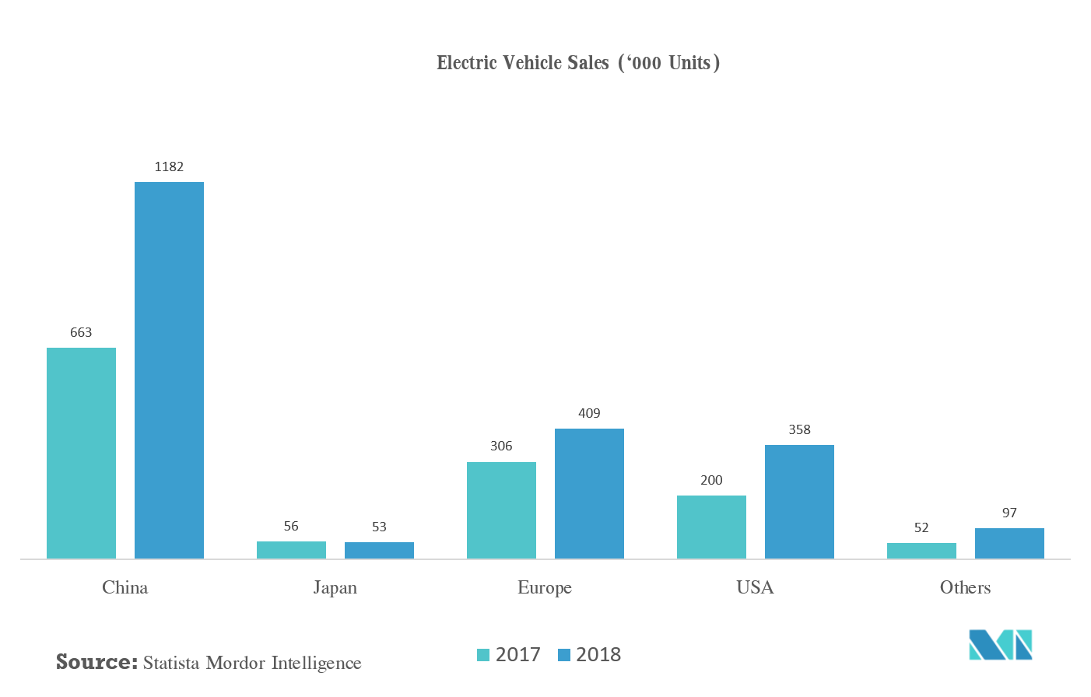

### ***Marketing Mix***

### ***ــــــــــــــــــــــــــــــــــــــــــــــــــــــــــــــــــــــ***

Today, with advent of new technologies and with increased competition, it is found that several organizations are deploying different and innovative marketing campaigns to increase the overall sales of the organization. The top-level management of these organizations need to launch new marketing strategies that will help them overcome the market challenges, market competition, and will also fulfil the sales objectives of the organization.

The organization, further, needs to conduct market research before directly implementing the marketing plan for the given products of the organization. They need to determine the price, promotional strategy, place of promotion, and identify key features of the product that will help them attract more customers toward the given product.

Also, the marketing team of the organization needs to make sure that they are not only able to achieve required objectives of the organization but are also able to achieve the objective of sustainability in a given work environment.

The company needs to overcome different marketing challenges of the environment and accordingly place the products in the market so that they can easily target them to the intended customers in a given market. This report will discuss the marketing plan and will identify key marketing strategies that will assist the organization in achieving desired marketing objectives of the organization.

# **Marketing Mix Tactics**

* ***Product***

The organization will be launching different product models that will have different performance capacities. Second, these products deliver high performance, offers other functionality compared to other vehicles, and also saves on pollution. Apart from design, technology, and quality, the product also offers safety and convenience to the customers.

Today, it is found that the issue of pollution related to different vehicles has increased in a given environment. Even, customers have become more aware of it and are searching for better products in the market that can help them resolve this issue. Hence, they might switch to such electric vehicles that can provide with similar performance, quality, and also assist in controlling pollution in a given environment.

Hence, the marketing department of the organization needs to focus on the aspects of controlling pollution and delivering high performance while preparing the marketing plan of the organization. They also need to demonstrate visuals and other forms or presentation to spread more awareness on the given product.

* ***Price***

The pricing of the product should be kept in alignment with the prices of other vehicles. Apart from the functionality of the given product, the top-level management can highlight certain features of the product such as technology, design, style, and other such features. It is important to deliver the message of sustainability through utilization of such vehicles to the intended customers.

It will help the company to remain competitive in the market environment and subsequently achieve more sales for the given products in the organization. It is important for the marketing team to determine the prices of other products in the market. They can also invest in research and development so that they can develop price-centric products for the customers.

The customers will be able to afford such products and hence the company can thereby target to a larger segment. It will subsequently help them achieve required targets from the sales perspective (Garay & González, 2012). However, the marketing team needs to monitor the pricing strategies on a frequent basis so that they can make necessary changes as and when required.

* ***Promotion***

This is one of the major elements of the marketing mix and plays a vital role in the sales of the products. The company needs to focus on the aspects of advertising and promotions and thereby prepare the marketing plan to sell the electric vehicles in the market. Advertisements will help the organization to increase the awareness levels of the products in a given market.

Similarly, promotions will help the company to introduce new launching offers in the market. The customers should be informed about such offers through different forms of advertisement. However, the marketing team also needs to take into account budget considerations and constraints before preparing the promotions plan for a given product. They need to thereby choose the marketing channels wisely and subsequently manage them from the budget perspective (Liu et al., 2010).

The costs associated with such forms of marketing are high and it is important for the marketing team to determine the most appropriate marketing channels and mediums. They also need to allocate budgets separately for digital marketing to reach the intended target audience.

Further, they also need to look out for promotions through in-store advertisements and thereby capture the attention of the audience. It is important to communicate the desired message of advertising and promotions through such means to these customers to achieve required sales targets for the organization.

* ***Place***

The organization needs to identify the places through which they will be able to sell these products. It is important to determine the stores and other such places from where these products can be delivered to the customers.

Further, the top-level management in association with the marketing department needs to identify the cities from where these products will be sold to the customers. They can thereby prepare the marketing strategies for each of the stores and accordingly sell the products from different locations.

They need to hire regional managers that will be looking after the sales and other processes of the organization. They will be also reporting to the senior management on the daily and monthly sales updates so that the top-level management can monitor the progress. They can also modify the strategies as and when required.

It will thereby help them achieve desired sales targets across different stores in multiples cities of a given nation. The marketing team, however, needs to carefully choose each of the store locations and also provide them with necessary support services to exceed the expectations of the customers.

### **Conclusion**

It is important for the marketing team to communicate clearly about the objectives of the organization to the staff. They need to be trained on the modules of sales marketing, services marketing, and other affiliates form of marketing. Only then they will be able to deliver results as per the expectations of the organization. Further, the marketing team needs to prepare the marketing plan after identifying the marketing mix for the given products - Electric Vehicles of the organization. They also need to undertake the market research before formulating the final marketing strategies of the organization.

The marketing team at the stores need to communicate clearly and explain about the major benefits of the product to the customers. They need to become more social and also focus on the services aspects of the product so that customers can get attracted to buy those products. It is important to think out-of-the-box for promotions to provide the best discount offers to the customers during the launching time.

It is equally important for the customers to get aware of such products and purchase them. The role of the marketing team in a given organization can thereby considered as vital from different perspectives. It will thereby help the organization to achieve required objectives in a given challenging environment.

### 

### ***Electric-vehicle infrastructure demand***

### ***ــــــــــــــــــــــــــــــــــــــــــــــــــــــــــــــــــــــــــــــــــــــــــــــــــــــــــــــــــــــــــ***

In the European Union, as EVs go mainstream, charging will likely shift toward public options and away from the home over time, with the share of home charging declining from approximately 75 percent in 2020 to about 40 percent by 2030. That’s because more middle- and lower-income households without home-charging options will buy EVs from 2020 onward. In China, public charging will dominate and increase in importance over time, going from 55 to 60 percent in 2020 to approximately 80 percent by 2030. The structural limitations of highly dense urban cities, which have larger proportions of on-street and large-commercial-garage parking, are the catalysts for increased public-charging demand.

In the near term, low levels of public charging should therefore not significantly hinder EV adoption in the European Union and United States. The situation looks different for China, where over half of the energy will come from public sources. Furthermore, the importance of public charging will likely grow stronger by 2030, reinforcing the need for strategies based on target-market needs.

As electric-vehicle demand looks increasingly likely to grow and EVs emerge as viable alternatives to ICE cars, an [ecosystem of industries](https://www.mckinsey.com/industries/automotive-and-assembly/our-insights/how-mobility-players-can-compete-as-the-automotive-revolution-accelerates) needs to stack hands on actions that can enable their broader use. Closing the charging gap is one such action, and resolving it will require a concerted, collaborative effort. That’s why finding the answers to the questions raised here should top the agendas of all stakeholders across the EV ecosystem, especially if charging access becomes the number-one impediment to EV penetration. Understanding specific local needs for early demand and adaptation will be the key to making effective targeted investments, matching demand and supply, and enabling quick returns on investments.

### Image result for Market structure with electric cars charging stations"

### ***SWOT Analysis***

### ***ــــــــــــــــــــــــــــــــــــــــــــــــــــــــــــــــــــــــــــــــــــــ***

We conducted a SWOT analysis to make sure our organization and product would be viable for development. Since our plan is to supply electric vehicle chargers as part of the EV Project, our target market becomes the company with the contract to build the infrastructure. This company is ETEC, part of ECOtality of North America.

Our goal is to win the contract as the supplier of choice for the charging stations. This will provide us with a significant advantage down the road because our chargers will be installed early in the adoption of electric cars. This is the best way to gain market share for us – to get it from the beginning.

Tesla Inc. was an American start-up powered by Silicon Valley. Tesla was named after **Nikola Tesla**, who was a very successful inventor and scientist of his time. He had remarkable achievements in Radio technology and electrical engineering of Serbian descent.

### *Tesla’s Strengths*

Let’s start with the strengths of Tesla Inc. that will include the positive aspects of the company, which have reinforced the position of Tesla to become one of the most dominant companies in the world.

The following factors which are believed to be Tesla’s stronger points have ensured the company’s profitability, expansion, and popularity, especially in the long term.

### **A Top Employer Company**

Any organization is as good as it employs. In the case of Tesla Inc., it is one of the key factors for the company’s remarkable success. Wall Street Journal reports that Tesla has emerged as an ideal company for employees due to its diversity and innovation-encouraging culture. It has recently been listed as one of the ideal places to work, attracting young jobseekers with fresh talents and energy. The company has also been featured in Forbes’ ‘[America’s Best Employer 2019](https://www.forbes.com/best-employers-by-state/#19c15202487a)’.

### *Tesla’s Weaknesses*

All the internal factors in a company which causes any damage or bounds performance evaluation are identified weaknesses in the SWOT Analysis. So, these are some of the shortcomings of Tesla’s organizational structure, which reduce its competitiveness and business growth.

### **Manufacturing Complications**

The higher standard of innovation, the greater will be mechanical complications and production risk factor. Tesla faces continuous launch, manufacturing and production ramp delays while launching their new vehicles and other products. For example, Tesla faced endless manufacturing challenges when they were about to launch Model X, which lead to constant delays for distribution. Similarly, the company went through extreme troubles while manufacturing Model X’s battery module assembly line at Gigafactory 1.

### *Tesla’s Opportunities*

The opportunity section of this SWOT Analysis emphasizes the emerging chances of growth for the company.  It is an external factor which, when identified, can help Tesla to improve its business performance, management structure, and strategic growth and other aspects.

### **Sales expansion in untapped Market**

The most significant opportunity for the company right now is the Asian market, which is still unsaturated in the field of automotive and renewable energy markets

### **Less Expensive Car**

Tesla is expensive due to its unconventional reliance on innovation, which requires maximum financial support to entertain new technology.

Recently, Tesla has launched Model 3, which is a more affordable version of Model S with less range, power, and fewer features. However, it is an excellent opportunity for Tesla to expand the size of their [audience market](https://bstrategyhub.com/target-the-right-customersniche-marketing-strategy-explained/).

### *Tesla’s Threats*

The threat factor is combined with the phenomenon which stops the company from taking full advantages of the benefits that can be derived from the available strengths. Therefore, these are the few threats which Tesla faces to maintain the business despite the unpredictable conditions of the market.

### **Product Liability Claims**

Despite Tesla’s premium quality assurance and high standards of manufacturing, the automobile industry, in particular, is accustomed to facing significant product liability claims which the company’s fears to be one of the biggest financial blows.

### ***Conclusion***

In this SWOT analysis for the company, we highlighted each of the strength, weakness, opportunity, and threat which Tesla faces in the market. To grow its market share and financial stability, Tesla needs to take vigorous actions. Yet there is no doubt that despite the negative factors, the company is an ultimate symbol of progress and innovation.

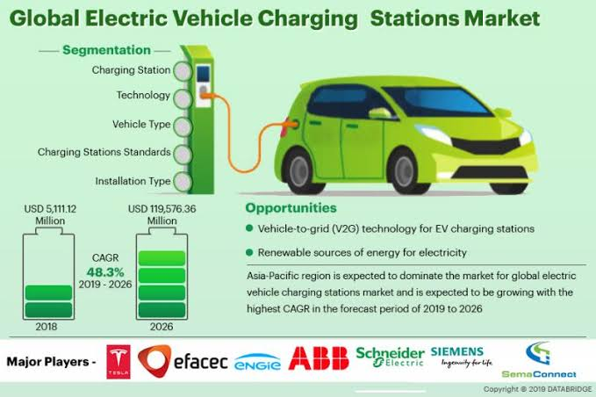

### ***Competitor analysis***

### ***ــــــــــــــــــــــــــــــــــــــــــــــــــــــــــــــــــــــــــــــــــــــــ***

A competitor analysis is an assessment of the strengths and weaknesses of the current and potential competitors within a defined industry. It can be described as a two-stage framework where the main components are competitor identification followed by competitor analysis.

By identifying, analyzing and accumulating knowledge about its competitors a firm can acquire strategic advantages. Competitor identification involves classifying and categorizing companies based on relevant similarities and differences, thereby assisting in creating an awareness of the competitive threats that exist. Competitors can be classified according to how competitive each competitor is deemed to be.

This step can be done by constructing a competitor array or performing competitor profiling, where a two-dimensional matrix can be constructed listing relevant data connected to the competitors.

### ***Electric vehicle charging stations market segmentation:***

### ***ــــــــــــــــــــــــــــــــــــــــــــــــــــــــــــــــــــــــــــــــــــــــــــــــــــــــــــــــــــــــــــــــــــ***

the electric vehicle charging stations market is segmented into the following categories:

### Electric Vehicle Charging Stations Market, by Vehicle Type:

* Battery Electric Vehicle (BEV)
* Plug-in Hybrid Electric Vehicle (PHEV)

### Electric Vehicle Charging Stations Market, by Charging Station:

* AC Charging Station
* DC Charging Station

### Electric Vehicle Charging Stations Market, by Installation Type:

* Residential
* Commercial

### Electric vehicle charging stations market, by Region:

* North America
* Europe
* APAC
* RoW

The global Electric Vehicle Charging Stations market is segmented into type of charger, application, power output, supplier type, and region. Based on Type of charger, the global Electric Vehicle Charging Station market is segmented into AC charging station and DC charging station. DC charging station dominated the global Electric Vehicle Charging Station and it is further expected to continue its dominance during the forecast period as well. Based on Type of application, the global Electric Vehicle Charging Station market is segregated into private and public. Public charging station emerged as a global leader as of 2018 with majority of the global market share. Based on Type of power output, the global Electric Vehicle Charging Station market is segregated into <11 kW, 11kW-50 kW, and >50 kW. Market segmentation based on supplier type, the global Electric Vehicle Charging Station market is segregated into OE Charging Station and Private Charging Station.

Geographically, the Electric Vehicle Charging Stations market has been segmented into North America, Europe, Asia Pacific, and Latin America and the Middle East & Africa (LAMEA).

North America dominates the global Electric Vehicle Charging Stations market owing to the increasing number of electric vehicles, stringent government regulations, and presence of electric vehicles manufacturers in the region. The U.S. is likely to hold major share of the North America electric vehicle charging stations market followed by Canada. Growing need of import-export through trucks and other transport vehicles in the U.S. and Canada is escalating the demand for electric vehicles and subsequently electric vehicle charging stations during the forecast period.

Europe electric vehicle charging stations market is the second leading region in the global market owing to the government policies of banning vehicles running on fossil fuels by 2025. Germany is expected to gross the largest share of the market due to increasing demand for electric vehicles and electric vehicle charging stations in the country followed by the U.K.

The Middle East is expected to gross low share of the global Electric Vehicle Charging Station market owing to the presence of ample amount of fossil fuel oil fields in the region.

Latin America is likely to experience significant growth with healthy CAGR owing to the rapidly increasing industrial sector in the region. Africa is forecasted to grow steadily over the next few years owing to increase in the number of favorable government regulations.

### ***Electric Vehicle Charging Stations Market Growth Forecast to 2023 - DC Charging Station Holds the Largest Market Share***

### ***ــــــــــــــــــــــــــــــــــــــــــــــــــــــــــــــــــــــــــــــــــــــــــــــــــــــــــــــــــــــــــــــــــــــــــــ***

Electric vehicles (EVs) are slowly gaining traction because of increasing greenhouse emission and strict pollution control standards enforced by environmental agencies. The boost in the adoption of EVs has created a favorable growth landscape for the electric vehicle charging stations (EVCS) market as well. The growing popularity and acceptance of EVs has resulted in increased installation of electric vehicle charging stations in the recent past.  The global electric vehicle charging stations market is expected to be valued at USD 30.41 billion by 2023, growing at a CAGR of 41.8% between 2018 and 2023.

Key factors driving the growth of the electric vehicle charging stations market include government funding, subsidies, and incentives, growing demand for electric vehicles, growing concern toward environmental pollution, and heavy investment from automakers in EVs. Vehicle-to-Gird (V2G) EV charging stations and charging stations powered by solar panels are the key opportunities for the players in the electric vehicle charging stations market.

Tesla is engaged in designing and developing electric cars and DC fast charging stations for its customers. Tesla is recognized to revolutionize the electro mobility ecosystem by manufacturing all electric production cars. The company's cutting-edge battery technology and electric powertrain, coupled with a rapidly growing fast charging network, has contributed in becoming one of the leading players in the electric vehicle charging stations market.

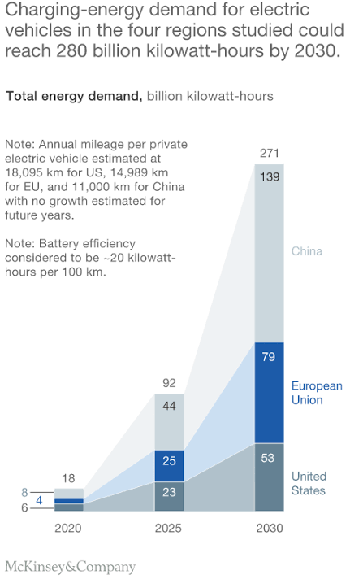



FORECASTING

Feasibility Study



Demand forecasting is a combination of two words; the first one is Demand and another forecasting. Demand means outside requirements of a[product](https://www.toppr.com/guides/business-studies/marketing/product/) or [service](https://www.toppr.com/guides/business-environment/business-functions/other-services/). In general,[forecasting](https://www.toppr.com/guides/fundamentals-of-economics-and-management/forecasting/) means making an estimation in the present for a future occurring event. Here we are going to discuss demand forecasting and its usefulness.

**Demand Forecasting**

It is a technique for estimation of probable [demand](https://www.toppr.com/guides/business-economics/theory-of-demand/meaning-and-determinants-of-demand/) for a product or services in the future. It is based on the analysis of past demand for that product or service in the present market condition. Demand forecasting should be done on a scientific basis and facts and events related to forecasting should be considered.

Therefore, in simple words, we can say that after gathering information about various aspect of the [market](https://www.toppr.com/guides/business-studies/marketing/market-and-marketing/) and demand based on the past, an attempt may be made to estimate future demand. This concept is called forecasting of demand.

For example, suppose we sold 200, 250, 300 units of product X in the month of January, February, and March respectively. Now we can say that there will be a demand for 250 units approx. of product X in the month of April, if the market condition remains the same.

**Usefulness of Demand Forecasting**

Demand plays a vital role in the [decision making](https://www.toppr.com/guides/business-management-and-entrepreneurship/planning/steps-in-decision-making/) of a business. In competitive market conditions, there is a need to take correct decision and make planning for future events related to business like a sale, production, etc. The effectiveness of a decision taken by business managers depends upon the accuracy of the decision taken by them.

[Demand](https://www.toppr.com/guides/business-economics/theory-of-demand/meaning-and-determinants-of-demand/) is the most important aspect for business for achieving its objectives. Many decisions of business depend on demand like production, sales, staff requirement, etc. Forecasting is the necessity of business at an international level as well as domestic level.

Demand forecasting reduces risk related to [business](https://www.toppr.com/guides/business-studies/nature-and-purpose-of-business/concept-and-characteristics-of-business/) activities and helps it to take efficient decisions. For firms having production at the mass level, the importance of forecasting had increased more. A good forecasting helps a firm in better [planning](https://www.toppr.com/guides/business-management-and-entrepreneurship/planning/planning-process/) related to business goals.

There is a huge role of forecasting in functional areas of [accounting](https://www.toppr.com/guides/principles-and-practice-of-accounting/meaning-and-scope-of-accounting/meaning-of-accounting/). Good forecast helps in appropriate production planning, process selection, capacity planning, facility layout planning, and inventory [management](https://www.toppr.com/guides/business-studies/nature-and-significance-of-management/introduction-to-management-and-its-characteristics-objectives/), etc.

Demand forecasting provides reasonable data for the organization’s [capital](https://www.toppr.com/guides/principles-and-practices-of-accounting/introduction-to-partnership-accounting/capital-accounts-fixed-and-fluctuating) investment and expansion decision. It also provides a way for the formulation of suitable pricing and advertisement strategies.

**Following is the significance of Demand Forecasting:**

* Fulfilling objectives of the business
* Preparing the [budget](https://www.toppr.com/guides/general-awareness/public-finance-and-budget/introduction-to-budget/)
* Taking management decision
* Evaluating performance etc.

Moreover, forecasting is not completely full of proof and correct. It thus helps in evaluating various factors which affect demand and enables management staff to know about various forces relevant to the study of demand behavior.

**The Scope of Demand Forecasting**

The scope of demand forecasting depends upon the operated area of the firm, present as well as what is proposed in the future. Forecasting can be at an international level if the area of operation is international. If the firm supplies its products and services in the local market then forecasting will be at local level.

The scope should be decided considering the time and cost involved in relation to the benefit of the information acquired through the study of demand. Cost of forecasting and benefit flows from such forecasting should be in a balanced manner.

**Types of Forecasting**

There are two types of forecasting:

* Based on [Economy](https://www.toppr.com/guides/economics/indian-economy-1950-1990/types-of-economies/)
* Based on the time period

**1. Based on Economy**

There are three types of forecasting based on the economy:

1. **Macro-level forecasting:** It deals with the general economic [environment](https://www.toppr.com/guides/geography/environment/environment/) relating to the economy as measured by the Index of Industrial Production(IIP), national income and general level of employment, etc.
2. **Industry level forecasting:** Industry level forecasting deals with the demand for the industry’s products as a whole. For example demand for cement in India, demand for clothes in India, etc.
3. **Firm-level forecasting:** It means forecasting the demand for a particular firm’s product. For example, demand for Birla cement, demand for Raymond clothes, etc.

**2. Based on the Time Period**

Forecasting based on time may be short-term forecasting and long-term forecasting

1. **Short-term forecasting:** It covers a short period of time, depending upon the nature of the industry. It is done generally for six months or less than one year. Short-term forecasting is generally useful in tactical decisions.
2. **Long-term forecasting casting:**Long-term forecasts are for a longer period of time say, two to five years or more. It gives information for major strategic decisions of the firm. For example, expansion of plant capacity, opening a new unit of business, etc.

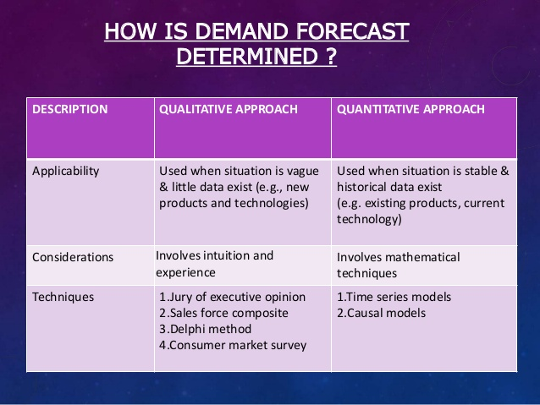

**The state of the electric vehicle market and its charging infrastructure**

The global electric vehicle population reached 3 million units at the end of 2017, which represents approximately 0.23% of the global vehicle population. Electric vehicle producers have responded to consumer's range anxiety by increasing the available range per charge in their vehicles to more than 200 miles. However ultimately the deployment of electric vehicles will depend on the deployment of ubiquitous chargers.

**Depending of the direction of mobility evolution, EV charging will have to adapt.**

This report provides an analysis of the state of deployment of public and private chargers by region including the USA, Europe, China and Japan. Technology, economic and social trends are dramatically changing the paradigm upon which the automotive industry has been built, this is man piloted, user owned and mass produced. Indeed the emergence of the autonomous and shared vehicle, both for personal and commercial mobility, is changing the needs of charging infrastructure. So what charging technologies can come forward to satisfy these special needs, these are presented in this report.

**The multibillion-dollar market opportunity in a complex landscape.**

Overall IDTechEx electric vehicle market research estimates that the global market of electric vehicle charging infrastructure will reach a market value of more than $140 billion by 2029 with a global population of ten million public chargers and 50 million private chargers.

IDTechEx's Electric Vehicle Charging Infrastructure 2019-2029 report presents an overview of the state of development of technologies for electric vehicle charging including conductive, inductive, and capacitive charging among others. The report presents the different charger topologies by different levels (Level 1 to Level 3). A comprehensive overview of the main charging standards (Chademo, CCS, Tesla, China GB dtd, India Bharat std) , communication protocols and standards including an analysis of Vehicle to Grid communication interphase. We present some of the key enabling technologies such as semiconductor technology, fast charging, battery swapping and robotic charging which will have a role in new mobility paradigms.

The coverage of this report is global. This report presents a ten year market forecast (2019-2029) of electric vehicle chargers by region (Europe, China, USA and Japan) and by type of charger (public or private). We provide profiles of leading companies developing and commercialising electric vehicle charging infrastructure. As public policies have always key for electric vehicle deployment we include some of the recent highlights of policies favourable for electric vehicle charging infrastructure globally.

The EV charging infrastructure value chain will evolve as the integrating of both electric vehicles and renewable energy goes forward. Challenges and opportunities arise when this happens, as there will be increasing requirements for operating the electricity network in a smarter way. For this purpose, concepts like demand side management and key enabling technologies like energy storage will have a key role.

Our report finishes with an outlook to the future, including a promising avenue of technology development that can potentially disrupt the electric vehicle charging infrastructure industry: this is energy autonomous vehicles. What we mean by this? Not fully autonomous of course but given the increasing performance of energy harvesting technologies we foresee a future in which electric vehicles will be capable of recharging themselves by harvesting energy from the environment and therefore become less reliant on grid-based charging infrastructures.

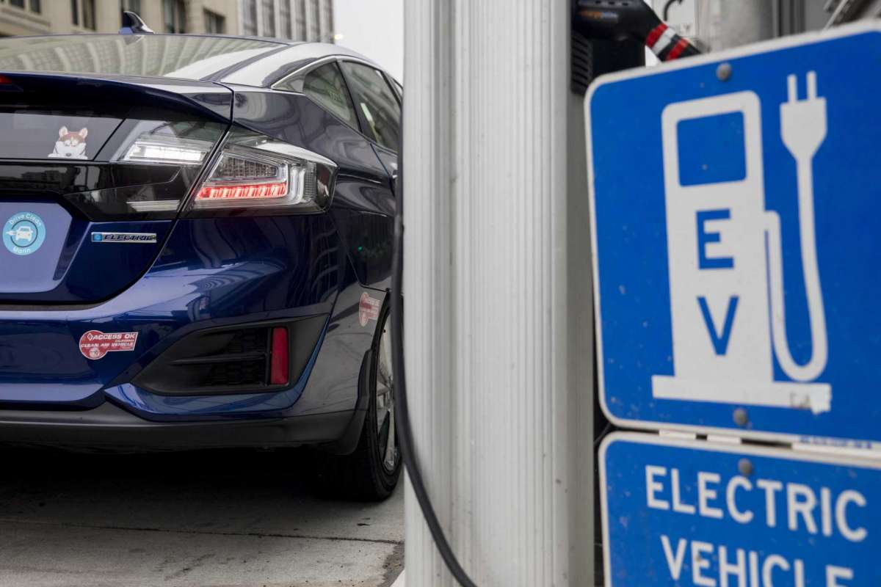 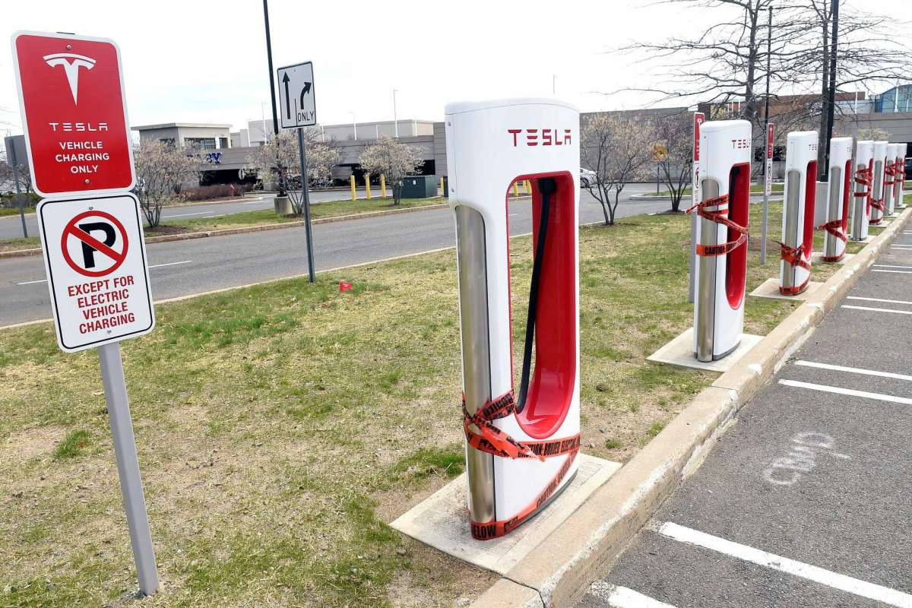

**Up to 40 Million EV Charging Points Forecast Worldwide by 2030**

Growth in electric vehicle sales worldwide is expected to boost demand for charging points, with up to 40 million installed by 2030, GTM Research predicts.

The analyst firm’s report, [*EV Charging Infrastructure Development*](https://www.greentechmedia.com/research/report/ev-charging-infrastructure-development-global-market-sizing-and-forecasts#gs.rGTiBhA), forecasts that 11 percent of new vehicle sales in 2030 will consist of electric models.

However, the rollout of charging infrastructure will vary widely according to geography.

**Europe**

Europe is expected to face growth trends similar to the U.S., with an estimated 9 million residential and 1.6 million public charging points set to be in operation by 2030.

But beyond the headline figures, Europe’s EV charging markets differ markedly from those in North America. One point of difference is that public administrations have been largely responsible for supporting early infrastructure build-outs.

Another is that electric utilities are also more engaged with the vehicle-charging market, by for instance making their own equipment or acquiring companies that are active in this space.

The U.K., said Gavrilovic, has seen a good example of cooperation between government, utility and charging network actors to support infrastructure build-outs. Southern European countries, meanwhile, have tended to lag, although there are pockets of growth.

An important development in Europe has been the rise of companies that offer EV roaming services, giving users access to multiple charging networks.

**Asia**

China’s eye-popping state-sponsored EV [charging infrastructure build-out](https://www.greentechmedia.com/articles/read/china-could-build-more-ev-chargers-than-the-rest-of-the-world-combined#gs.bsRatCo) has been well documented. But authorities are now realizing they may have built too much, too soon, said Gavrilovic. “The utilization levels are really low,” he commented.

This will likely lead to a trimming of national infrastructure targets, he said. In the meantime, other Asian countries are getting in on the act, with Japan also pursuing an aggressive fast-charging build-out strategy.

South Korea has not yet achieved the momentum seen in China or Japan, but is beginning to see increasing activity.

Finally, India “is definitely a geography to keep an eye on,” said Gavrilovic, purely because its size and population make it highly likely to experience localized EV growth.

**The rest of the world**

North America, Europe and Asia are set to dominate EV charging infrastructure rollouts up to 2030, but there is growing activity across the Southern Hemisphere, too. Quantifying this is challenging due to a lack of data, Gavrilovic said.

But in Latin America, for example, Brazil has been piloting the use of infrastructure, and Chile is set to lead growth in the region. Mexico, too, is expected to see some growth in charging infrastructure even though projections of its EV adoption rate remain muted.

Africa is even further behind the curve. In Australia, though, there is not only a growing build-out of infrastructure, which now pretty much [encircles the country](https://www.news.com.au/technology/innovation/motoring/hitech/electric-vehicle-charging-network-now-spans-almost-all-of-australia/news-story/217f5b2f41269cca37de3083b582bb25), but also an active equipment manufacturing and installation industry that hopes to target Asian markets.

The challenge facing Australia, as in many other parts of the globe, is that while charging infrastructure makes sense in cities, its high cost means there is not much of an incentive to install it in rural areas. “There’s a challenge of geography there,” said Gavrilovic.

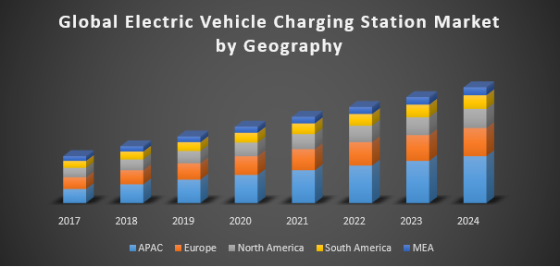

**Short-Term Load Forecasting for Electric Vehicle Charging Stations**

Short-term load forecasting is a key task to maintain the stable and effective operation of power systems, providing reasonable future load curve feeding to the unit commitment and economic load dispatch. In recent years, the boost of internal combustion engine (ICE) based vehicles leads to the fossil fuel shortage and environmental pollution, bringing significant contributions to the greenhouse gas emissions. One of the effective ways to solve problems is to use electric vehicles (EVs) to replace the ICE based vehicles. However, the mass rollout of EVs may cause severe problems to the power system due to the huge charging power and stochastic charging behaviors of the EVs drivers. The accurate model of EV charging load forecasting is, therefore, an emerging topic. In this paper, four featured deep learning approaches are employed and compared in forecasting the EVs charging load from the charging station perspective. Numerical results show that the gated recurrent units (GRU) model obtains the best performance on the hourly based historical data charging scenarios, and it, therefore, provides a useful tool of higher accuracy in terms of the hourly based short-term EVs load forecasting.

**What Is Trend Forecasting?**



Trend forecasting is a complicated but useful way to look at past sales or market growth, determine possible trends from that data and use the information to extrapolate what could happen in the future. Marketing experts typically use trend forecasting to help determine potential future sales growth. Many areas of a business can use forecasting, and examining the concept as it relates to sales can help you gain an understanding of this strategy.

**Forecasting Using Patterns**

Looking at data over a number of years and finding patterns, you can use this information to predict future patterns. A trend means the same series of events is happening over and over. For example, if there is a trend of constant sales each year with a decrease of sales in winter that is offset by an increase in the summer, a person might use this pattern to predict that sales will continue to be low in the winter. Put into action, a store manager might offer additional products in the winter to help hedge against the expected drop in sales.

However, forecasting isn't done quickly by just looking at a graph. Forecasters may translate the a graph's patterns into a formula to accurately predict what will happen in the future. They often use spreadsheet software that comes with built-in trend forecasting tools.

**Trend Forecasting with Caution**

Trend forecasting is scientific, but it is also uncertain. The longer into the future a forecast is applied, the more uncertain the results become. Unexpected events can happen that will disrupt a steady pattern, like stock market downturns changing consumer behavior and dramatic shifts in users' access to certain technologies. The more complicated a pattern appears to be, the more uncertain a trend forecast is.

**FORECAST ACCURACY**



In statistics the accuracy of forecast is the degree of closeness of the *statement* of quantity to that quantity’s actual (true) value. The actual value usually cannot be measured at the time the forecast is made because the statement concerns the future. For most businesses, more accurate forecasts increase their effectiveness to serve the demand while lowering overall operational costs.

In this article, we adopt a statistical viewpoint primarily relevant to commerce and manufacturing, especially for inventory optimization and demand planning areas.

**Use of the accuracy estimates**

The accuracy, when computed, provides a **quantitative estimate of the expected quality of the forecasts**. For inventory optimization, the estimation of the forecasts accuracy can serve several purposes:

* to choose among several forecasting models that serve to estimate the [lead demand](https://www.lokad.com/lead-demand-definition) which model should be favored.
* to compute the [safety stock](https://www.lokad.com/calculate-safety-stocks-with-sales-forecasting) typically assuming that the forecast errors follow a normal distribution.
* to prioritize the items that need the most dedicated attention because raw statistical forecasts are not reliable enough.

In other contexts, such as strategic planning, the accuracy estimates are used to support the what-if analysis, considering distinct scenarios and their respective likelihood.

**Impact of aggregation on the accuracy**

It is a frequent misconception to interpret the quality of the forecasting model as the primary factor driving the accuracy of the forecasts: this is not the case.  
  
The most important factor driving the value of the accuracy is the **intrinsic volatility** of the phenomenon being forecasted. In practice, in commerce or manufacturing, this volatility highly correlated to the aggregation level:

* larger areas, such as national forecasts vs local forecasts, yield more accuracy.
* idem for longer periods, such as monthly forecasts vs daily forecasts.

*Anecdotal evidence:* At Lokad, we routinely observe that there is no such thing as a *good* accuracy; it’s specific of the context. When forecasting the next-day nationwide electricity consumption for a large European country, 0.5% of error was considered as relatively inaccurate; while achieving less than 80% of error for the store-level forecasts of the first day of sales of newly introduced fresh products was considered a significant achievement.

Then, once a level of aggregation is given, the quality of the forecasting model plays indeed to primary role in the accuracy that can be achieved. Finally, the accuracy decreases when looking further ahead in the future.

**Empirical accuracy vs real accuracy**

The term *accuracy* is most frequently used referring to quality of a physical measurement of some kind. Unfortunately, this vision is somewhat misleading when it comes to statistical forecasting. Indeed, unlike the physical setup where the measurement could be compared to alternative methods, the **real accuracy** of forecast should be strictly measured **against data you don’t have**.  
  
Indeed, once the data is available, it is always possible to produce perfectly accurate forecasts, as it only requires mimicking the data. This single question has kept statisticianspuzzled for more than a century, as a deeply satisfying viewpoint has only been found at the end of the 20th century with the advent of Vapnik-Chervonenkis theory (1).  
  
The accuracy of the forecasts can only be practically measured against available data; however, when the data is available, those *forecasts* aren’t true forecasts anymore, being statements about the past rather than being statements about the future. Thus, those measurements are referred as the **empirical accuracy**, as opposed to the **real accuracy**.  
  
[Overfitting](http://blog.lokad.com/journal/2009/4/22/overfitting-when-accuracy-measure-goes-wrong.html) problems can lead to large discrepancies between the empirical accuracy and the real accuracy. In practice, a careful use of backtesting can mitigate most overfitting problems when forecasting [time-series](https://www.lokad.com/what-is-time-series-forecasting).

**Popular accuracy metrics**

There are many metrics to measure accuracy of forecasts. The most widely used metrics are:

* MAE (mean absolute error)
* MAPE (mean absolute percentage error)
* MSE (mean square error)
* sMAPE (symmetric mean absolute percentage error)
* [Pinball loss](https://www.lokad.com/pinball-loss-function-definition) (a generalization of the MAE for [quantile forecasts](https://www.lokad.com/quantile-regression-(time-series)-definition" \o "Quantile regression Definition - Inventory Optimization Software))
* [CRPS](https://www.lokad.com/continuous-ranked-probability-score) (a generalization of the MAE for [probabilistic forecasts](https://www.lokad.com/probabilistic-forecasting-definition))

In practice, a metric should be favored over another based on its capacity to reflect the costs incurred by the company because of the inaccuracies of the forecasts.

**Lokad’s gotcha**

It’s better to be approximately correct than exactly wrong. In our experience dealing with commerce or manufacturing companies, we routinely observe that too little attention is paid to the choice of the accuracy metric.  
  
Indeed, the *ideal* metric should not return values expressed as percentages, but should return Dollars or Euros, precisely **reflecting the cost of the inefficiencies caused by the inaccurate forecasts**. In particular, while most popular metrics are symmetric (the pinball loss being a notable exception), risks of overforecasting vs underforecasting are not symmetric in practice. We suggest adopting a viewpoint where the metric is closer to an economic cost function – carefully modeled to fit the business constraints – rather than a raw statistical indicator.  
  
Also, it's quite important not to perform any planning implicitly assuming that the forecasts are *exact*. Uncertainty is unavoidable in business and should be accounted for.